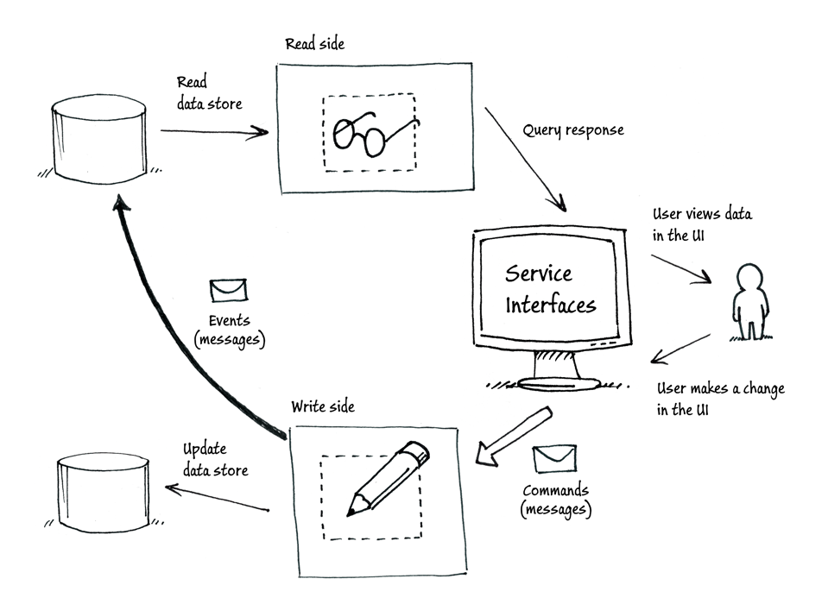

The object or objects on the read side contain only query methods, and the objects on the write side contain only command methods.

Commands are imperatives;
they are requests for the system to perform a task or action.

Events are notifications;
they report something that has already happened to other interested parties. For example, "the customer's credit card has been billed $200" or "ten seats have been booked for conference X." Events can be processed multiple times, by multiple consumers.

Both commands and events are types of message that are used to exchange data between objects. In DDD terms, these messages represent business behaviors and therefore help the system capture the business intent behind the message.
A possible implementation of the CQRS pattern uses separate data stores for the read side and the write side; each data store is optimized for the use cases it supports. Events provide the basis of a mechanism for synchronizing the changes on the write side (that result from processing commands) with the read side. If the write side raises an event whenever the state of the application changes, the read side should respond to that event and update the data that is used by its queries and views.

